**TOP TEN BEST IT SCHOOLS IN GHANA**

Information technology (IT) is the use of computers to store, retrieve, transmit, and manipulate data or information. It is a subset of Information and Communications Technology (ICT).

Is it your dream to become a Chief technology officer, a Software programmer, or a [**Computer Analyst**](https://worldscholarshipforum.com/forensic-computer-analyst/)**,** or simply a technological expert to advance your career? You have to begin by choosing one of the best Information Technology schools in Ghana.

Information technology has so far been a fast field that is catching up with massive advancements every day. The world is vastly linked to technology, it has become part and parcel of our lives. Hence, finding the best technology schools in Ghana has become the desire of many students.

Technology is applied in all aspects of our lives, which has created a large number of opportunities available, that can be utilized by Ghanaians. Getting to know the best computer programming schools in Ghana, can help you make your choice of where to attend. This analysis is based on the facilities, teaching staff, and the general performance of the school.

1. **IPMC Ghana**

IPMC is west Africa’s largest IT company. Since their inception in 1992, they are committed to bringing the latest technology solutions to increase the productivity and efficiency of businesses.

IPMC in the last 27 years has become a household name and known in the industry for its leadership in assisting to develop a digital economy through its system integration expertise, software development and IT skills development programme

The modern labs at their technology centres ensure that students' learning is enhanced by grasping the theoretical principles of science taught in classrooms. The experienced lecturers create further professional exposure through industry visits and networking with peers.

IPMC computer school Accra is a fully-fledged institution that offers all knowledge and skills to learners relating to the IT sector. The school offers online courses to learners, who are a little distant from the school due to some circumstances and those who want to study for some time. They offer affiliate courses that are highly valued in the industry.

Students are awarded international certification after graduating. Most job markets and employees, trust the skills and capabilities of learners from this institution since they are guided by highly trained and experienced teachers. The institution believes in internships of the learners as an avenue for them to get familiar with the industry.

CONTACT

Email: [**sales@ipmcghana.com**](mailto:sales@ipmcghana.com)**,** [**training@ipmcghana.com**](mailto:training@ipmcghana.com)

Phone: +233 0302 226830/90, [**+233 (0)55-555-2222**](tel:%20+233%20(0)55-555-2222;)  
Head Office: 62, KOJO THOMPSON ROAD, ADABRAKA, ACCRA – GHANA

**[P. O. Box AN 7617, Kwame  
Nkrumah Avenue Accra, Ghana](https://www.ipmctraining.com/aboutUs)**

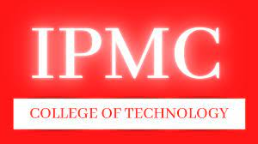

1. **OpenLabs (NIIT Ghana)**

OpenLabs (previously NIIT Ghana) is the most well-known name in West African IT education. Established in 1999, OpenLabs has played a pivotal role in Ghana's technology transformation over the last 20 years, by cultivating generations of industry-ready computer graduates. Their main campus is at Ring Road in Accra with centres in Tema, Kumasi, Takoradi and Tamale.

We are best recognized for our training, consulting, and content production capabilities. OpenLabs offers a diverse selection of education programs that appeal to people from all walks of life, from businesses with growing training needs to individuals seeking IT and related skills.

The school has formed strategic alliances with Microsoft, IBM, Google for Education, Huawei, ATHE, and other internationally renowned organizations.

OpenLabs strives to provide excellent IT education to businesses and individuals by combining hands-on tech skills training, strong disciplinary knowledge, and a drive for entrepreneurial abilities to create a sustainable Africa fuelled by new-age technology.

It is certainly among the top IT schools in Ghana because it is well facilitated with ultra-modern technological teaching equipment. They also have trained and skilled staff that are willing to help the students to get to the top in the information technology sector. They have many great and successful alumni who owe their achievements from the training received in this great institution.

They offer deep technical programmes that prepares students for a full-time engineering and developer career such as Diploma in Software Development, Network Engineering, Digital Design, Data Science, Network Administration and Certificate programmes in Microsoft Office, Data Analytics, Cybersecurity and much more.

CONTACT

OPENLABS RING ROAD CAMPUS:

276/3, Ring Road Central, Opposite Busy Internet, Accra

T**el:**[**028-9116317**](tel:0289116317)**,**[**054-0124191**](tel:0540124191)**,**[**055-6587130**](tel:055-6587130)

**E-mail:**[**accra@openlabs.edu.gh**](mailto:accra@openlabs.edu.gh)

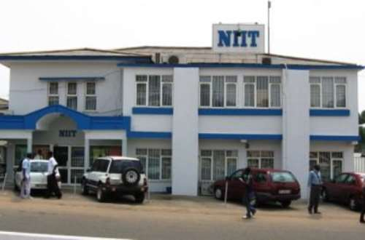

1. **Ghana Communication Technology University College**

Ghana Communication Technology University (GCTU) is a technology-oriented institution of higher learning, committed to providing an educational experience of the highest quality. Established in November 2005, it gained full public University status on 13th August 2020.

Currently, GCTU offers world-class Certificate, Diploma, and Degree programs under the Faculty of Computing and Information Systems. The University also runs a Graduate School which delivers postgraduate programs in the areas of Information Communication Technology.

Graduates of GCTU have the theoretical knowledge and hands-on experience that equip them for successful careers in the telecommunications, and ICT industries.

The University has campuses located at Tesano (main campus), Abeka, Kumasi, and learning centers in Ho, Koforidua, Takoradi, and Nungua. The focus on preparing graduates for the telecommunications and ICT profession is the hallmark of GCTU.

It is no surprise to include them among the best IT schools in Ghana. Programs include Mobile computing, information Technology, Hardware and software, Artificial intelligence

The faculty of computing and Information Systems offers BSc. Information Technology, BSc. Informatics, BSc. Mobile Computing, BSc. Computer Science, BSc. Software Engineering and BSc. Business Information Systems

CONTACT

Tel: +233(0) 302 221446/302 21412/302 221479

EMAIL: info@gctu.edu.gh

ADDRESS:

Digital Adress: GA-167-2979  
PMB 100, Tesano, Accra – Ghana  
Off J.A Kuffour Avenue, Adjacent the Police Training School, Tesano, Accra

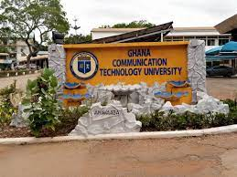

1. **Accra Institute of Technology**

The Accra Institute of Technology (AIT), is an independent technology-focused [research university](https://en.wikipedia.org/wiki/Research_university) based in [Accra](https://en.wikipedia.org/wiki/Accra), [Ghana](https://en.wikipedia.org/wiki/Ghana).

The university received the Best Technology University in Ghana Award for a number of years

The university is modelled on internationally renowned institutes of technology like the Massachusetts Institute of Technology (MIT) and the California institute of Technology (CALTECH) - both universities are consistently ranked in the top ten of the global rankings of universities worldwide.

They offer different ranges of study programs such as certificate and diploma of Technology (CTech & DTech), Bachelor of Science (BSc) and Industrial-Based (DTech). This school well equipped with modern training equipment and have a highly skilled instructor. Upon completion of the course, students are awarded accredited certification that is recognized by all of the employers in the Ghanaian job market.

CONTACT

Street Address

Accra Institute of Technology (AIT)

University Tower Seaview Campus, Weija

P.O. Box AN-19782, Accra-North, Ghana.

Phone & Email

+233 57 766 8812, +233 57 766 8817,  
+233 30 278 6053

[**ait@ait.edu.gh**](mailto:ait@ait.edu.gh)

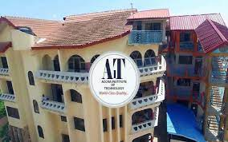

1. **Regent University College of Science and Technology**

The Regent University College of Science and Technology is located in Accra, Ghana and received accreditation to operate as a tertiary institution in 2004. Now, the University operates from its purpose-built campus, located at McCarthy Hill, off the Mallam-Kasoa-Winneba Highway.

 It is recognized as one of the leading private science and technology Universities in Ghana. Their School of Engineering, Computing and Allied Sciences (FECAS) provides ICT-based university education.

 The following are the departments under the school and the undergraduate degree programmes they offer:

* Department of Informatics: BSc (Hons) Computer Science, BSc (Hons) Information Systems Sciences
* Department of Engineering & Mathematical Sciences: BEng (Hons) Applied Electronics & Systems Engineering**,** Telecommunications Engineering Option**,** Computer Engineering Option**,** Instrumentation Engineering Option

The students are taught to use the skills learned in class to be creative and come up with solutions to some of the problems facing the IT industry in Ghana.

CONTACT

|  |  |
| --- | --- |
| Address: | Opp. Mendskrom Motel, McCarthy Hill |
| Postal address: | DS 1636 |
| Mobile: | 024 3173895 028 9114832 |
| Email: | [**info@regentghana.net**](mailto:info%40regentghana.net)[**regent@rucst.edu.gh**](mailto:regent%40rucst.edu.gh) |

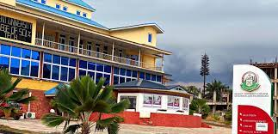

1. [KNUST Department Of Information Technology](https://myhealthbasics.site/knust-department-of-information-technology/)

Kwame Nkrumah University of Science and Technology (KNUST) is a public [University](https://en.wikipedia.org/wiki/University) of Ghana that focuses on science and technology

Established in 1977, the Department of Computer Science in KNUST serves as a center for computing education and research at both the undergraduate and graduate levels. There are strong research groups focusing on areas such as Artificial Intelligence, Cyber Security, Information Systems, Computer theory and Scientific computing, and Software Engineering. The goal of these groups is to use technology as a means to address national and international issues and to foster national development.

The Department of Computer Science offers in-depth training for students with sound academic background in Mathematics and Science and who are aspiring to become professionals in the field of Information Technology.

The primary goal of the department is to produce and provide the public sector of the nation as well as private organizations and institutions with world class Computer Programmers, Computer Analysts, System Analysts and Management Information Specialists.

The Department also offers research opportunities for graduate studies with well- equipped computer laboratories and other research facilities.

The Department was the first Department in the country to start a degree programme in Computer Science as such, in late 2007, the Department was presented with an award during the first Information Communication and Technology Award night.

Their programmes include BSc Computer Science, BSc. Information Technology, MSc/MPhil Computer science and MSc/MPhil Information Technology

CONTACT

 Kumasi, Ghana

T: +233 3220 60021 / +233 5000 99299

E: uro@knust.edu.gh

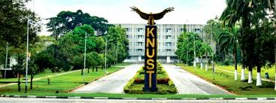

1. **University of Ghana Department of Information Technology**

The University of Ghana is the oldest and largest of the thirteen [Ghanaian](https://en.wikipedia.org/wiki/Ghana) national public universities. It was founded in 1948, and gained full university status in 1961.  The University of Ghana is situated on the West view of the [Accra](https://en.wikipedia.org/wiki/Accra) Legon hills and at the northeast of the centre of Accra

The original emphasis on establishing the University of Ghana was on the liberal arts, social sciences, law, basic science, agriculture and medicine. However, as part of a national educational reform program, the university's curriculum was expanded to provide more [technology](https://en.wikipedia.org/wiki/Technology)-based courses

CONTACT

+233-(0)302-213820

+233-(0)302-213850

[**pad@ug.edu.gh**](mailto:pad@ug.edu.gh)

P.O. Box LG 25  
Legon, Accra

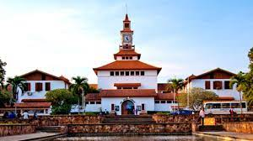

1. [**UCC Department of Computer Science and Information Technology**](https://myhealthbasics.site/ucc-department-computer-science-information-technology/)

The University of Cape Coast was established in October, 1962 as a University College and attained the status of a full and independent University on October 1, 1971. It is a public collegiate university located in the historic town of [**Cape Coast**](https://en.wikipedia.org/wiki/Cape_Coast)**.**

The university was established in response to the country's dire need for highly qualified and skilled manpower in the education sector. Its original mandate was therefore to train graduate teachers for second cycle institutions, teacher training colleges and technical institutions.

With the recent developments and trends in the information technology (IT), the University of Cape Coast established an academic department known as the Department of Computer Science and Information Technology. The primary focus of this department is teaching and research in computing.

 It’s academic program in Computer Science and Information Technology aims to provide students with a firm foundation in the field of Computer Science and its applications and prepare them to become an effective computer science professional.

The Department offers three programs: BSc Computer Science, BSc Information Technology and a PhD in Computer Science and Application. These programs provide a comprehensive education in both theoretical and practical aspects of Computer Science (CS) and Information Technology (IT).

CONTACT

The Registrar, University of Cape Coast, Cape Coast, Ghana.

**+233 [03321]32440, +233 [03321] 32480-9**

[**registrar@ucc.edu.gh**](mailto:registrar@ucc.edu.gh)

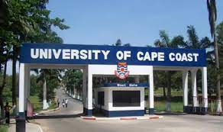

1. **Aptech Computer Education**

Aptech Limited, established in 1986, operates the world's largest IT training network with over 4000 high quality training centers spread across 5 continents. It is currently the only Computer Training institution in Ghana offering ISO Certified Programs in Information Technology.

The school’s partnership with Microsoft, it’s state of the art facilities, their years of experience, and well-trained facilitators who deliver practical IT skills, makes them one of the best in Ghana.

The institution courses are: Hardware & Networking (ACNS), Software Engineering (ACCP) and Ethical Hacking. Students are given projects which are monitored by instructors in order to check their step by step progress and offer assistance to other students placing them among best IT schools in Ghana. The institution specializes in offering technological solutions to all students.

CONTACT

Address

Jislah place, HQHV+68X, Wawa Road,Kokomlemle Accra

Phone (+233) 026 630 6021

Email: info@aptechghana.com



1. **AITI-KACE**

**Advanced Information Technology Institute- Kofi Annan Centre of Excellence (AITI-KACE) is a Ghana-India Kofi Annan Centre of Excellence in ICT established in 2003 as an ICT Capacity Development Agency under the Ministry of Communications and Digitalisation, Government of Ghana.**

**The core aim of the Centre is to promote individual and institutional capacity building; research and innovation; consultancy and advisory services in the area of ICT and eGovernance solutions in Ghana and Africa.**

**For over 20 years, AITI-KACE boasts of a strong multi-disciplinary team that has a well-established track record of working in over 10 African countries.**

**The school has modern facilities and boasts of Ghana’s first super computer ‘Param Padma’.**

The school’s vision is to be a Centre of excellence in ICT and eGovernance,  
Promoting Research and Innovation, human & institutional Capacity building,  
​ Consultancy services and setting standards for ICT and eGovernance solutions

AITI coordinates and oversees an ICT system that produces globally competitive research and Innovation through quality oriented and demand-driven learning for national development

CONTACT

Accra +233 556 660 355

Sunyani +233 201 505 489

Bolgatanga +233 201 505 407

Bolgatanga & Sunyani Centres

Bolgatanga Centre

Ministries

Digital Address: UB-0032-2250

Sunyani Centre

off new Dormaa Road,opp medical village

Digital Address: BS-0051-1845

